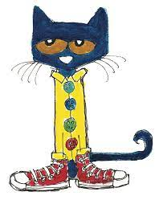
Reading is Groovy!

Dear parents/guardians,
Reading helps us become lifelong learners and opens up a whole world of possibilities for all of us! At William Konkin Elementary, we are encouraging students to read at home through a reading club! The theme is “Reading is Groovy”. The idea is that students read – or are read to – at home for 15 minutes per day. The parent/guardian will fill in the reading club sheet (just once per day, please and thank you!) on the opposite side of this page, and the child will return the full sheet to the Library during schoolwide book exchange or the class’s designated weekly library time. The child’s name will be added to the ‘Reading is Groovy’ bulletin board in the Library Learning Commons, and they can also select a prize. They then bring home another sheet for the next reading period. Thank you to the PAC for generously funding this program!
Thanks in advance for your support of literacy.

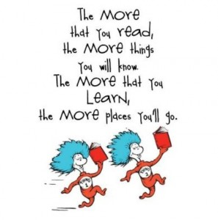
Happy reading!!!

Shawnese Trottier
Teacher-Librarian

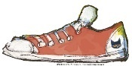
Reading Club 125

Date | Parent Initials | Date | Parent Initials
101 |  | 114
102 |  | 115
103 |  | 116
104 |  | 117
105 |  | 118
106 |  | 119
107 |  | 120
108 |  | 121
109 |  | 122
110 |  | 123
111 |  | 124
112 |  | 125
113

Child’s name: _____________________
Child’s teacher: ___________________
Parent Signature: __________________

